What is PCI Compliance?

The Payment Cards Industry, also known as the PCI, requires any entity that can receive funding by Credit or Debit Card to be PCI Compliant. This means all nonprofits and for-profit businesses that can receive funding by payment cards must complete an online assessment. At the end of the assessment, you will be asked to attest legally that you have answered all questions honestly, and to the best of your knowledge.

The good news is, becoming compliant is easy, and can typically be completed within
about 15 minutes. Once compliant, your compliance status lasts for 1 year. You’ll need to complete the 15-minute process annually.

When organizations do NOT become compliant, they are subject to fines assessed by the PCI. These fines can range between $29 - $59/month. We, at iDonate, certainly want to help you avoid these fines! We have created this walkthrough document to help you easily become PCI Compliant.

Let’s get started!

First, you’ll need to login to CardPointe.com. If you do not know your login information, you can reach out to helpdesk@idonate.com for assistance.

Once logged in, click on “My Account” from the top menu (seen in orange in the screenshot below):

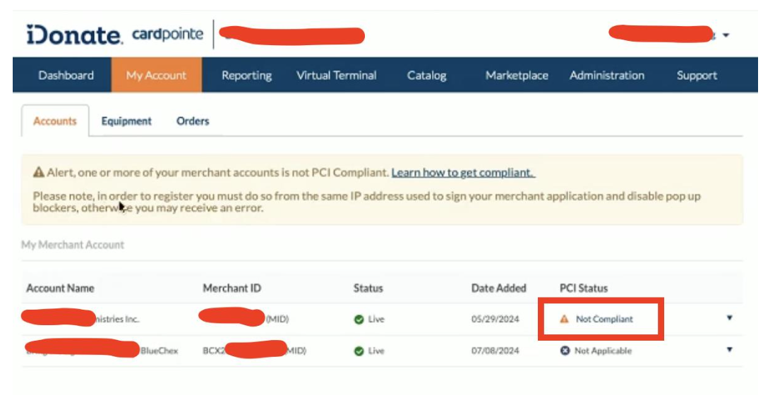
From the above screen, you’ll find your company name listed under “Account Name” and you’ll see “Not Compliant” under the PCI Status Column. Click on “Not Compliant.”

It is possible you’ll see additional lines with a PCI Status of “Not Applicable,” as seen above. These represent Merchant Accounts associated with eCheck processing, which is not related to the Payment Cards Industry, and therefore is not applicable for PCI Compliance.

From here, you should be redirected to a new website called Manage PCI. If you are not redirected, make sure your Pop-up blocker is not turned on. Your pop-up blocker can prevent you from getting to the next screen. Please note you may see some notifications, and you may be asked to enter some basic information about your business.

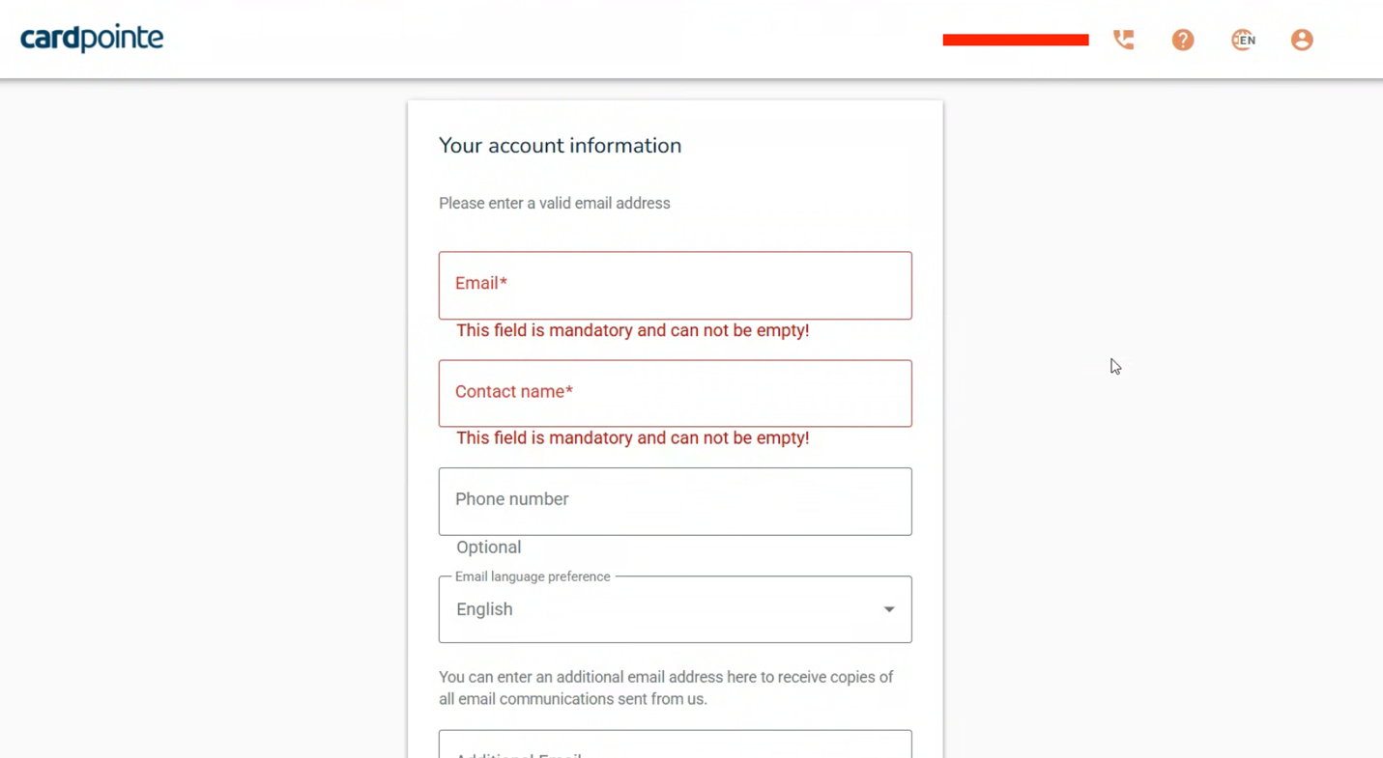

You may also be shown some legal notices and terms.

Agree to all notices and keep moving forward until you get to this screen:

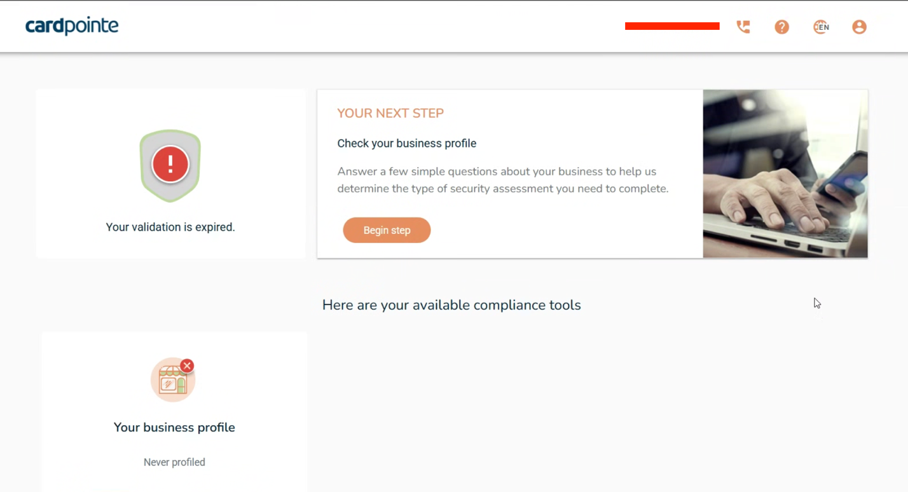

- If this is your first time completing the PCI Compliance, your screen will look like the one above. Click the “Begin Step” button.

- If this is NOT your first time, you will see additional available compliance tools. Your next step is to Check your business profile.

With iDonate, you need to have a Business Profile type of:
SAQ Type A

- If it looks like your Business Profile is already complete, as indicated with a GREEN CHECK MARK, as seen in this screenshot:

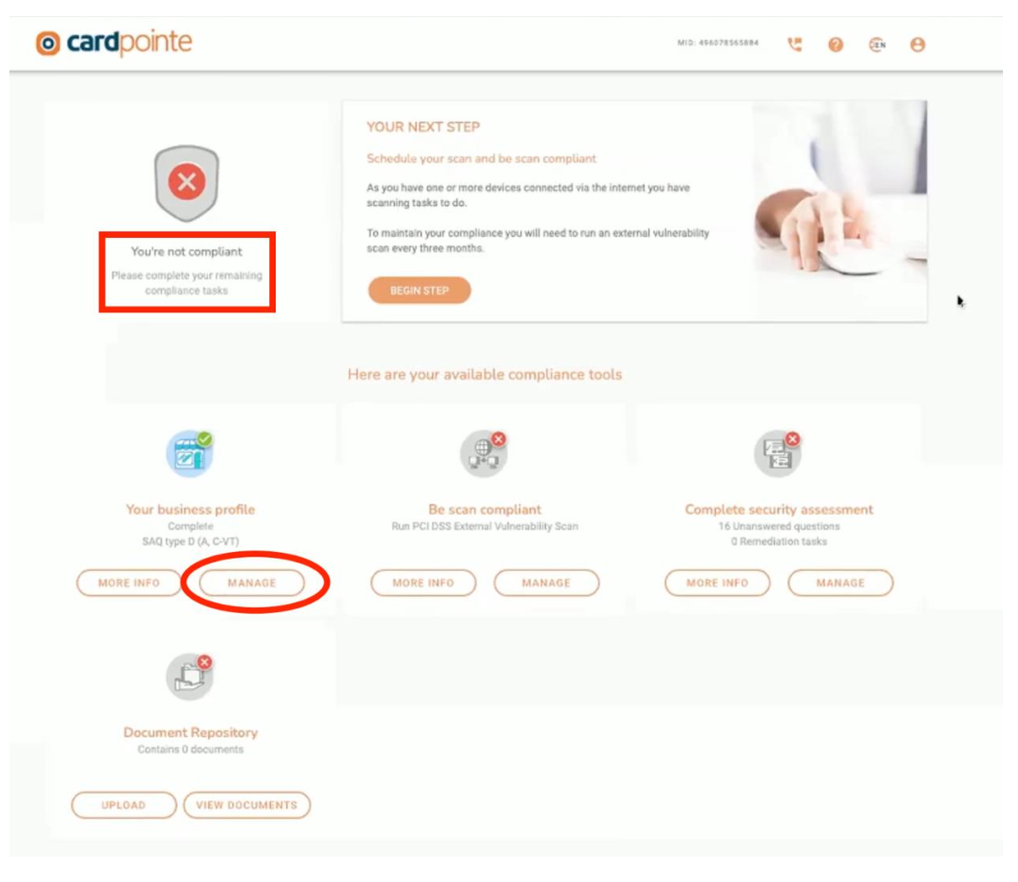

Check to see if it is a “Type A” profile.

*Notice the Screenshot above shows that the customer has an “SAQ type D” profile.
If it is NOT a type A Profile, as seen in the screenshot below, Click “Manage” to re-do your Profile.
How to Complete your Business Profile and get an SAQ Type A Status

Begin your Business Profile by either clicking on the “Manage” button, or if you see it telling you that your next step is to Check Your Business Profile, then click “Begin Step.”

You’ll come to a screen that will tell you “What’s Next.” Simply click “Start Business Profile.”

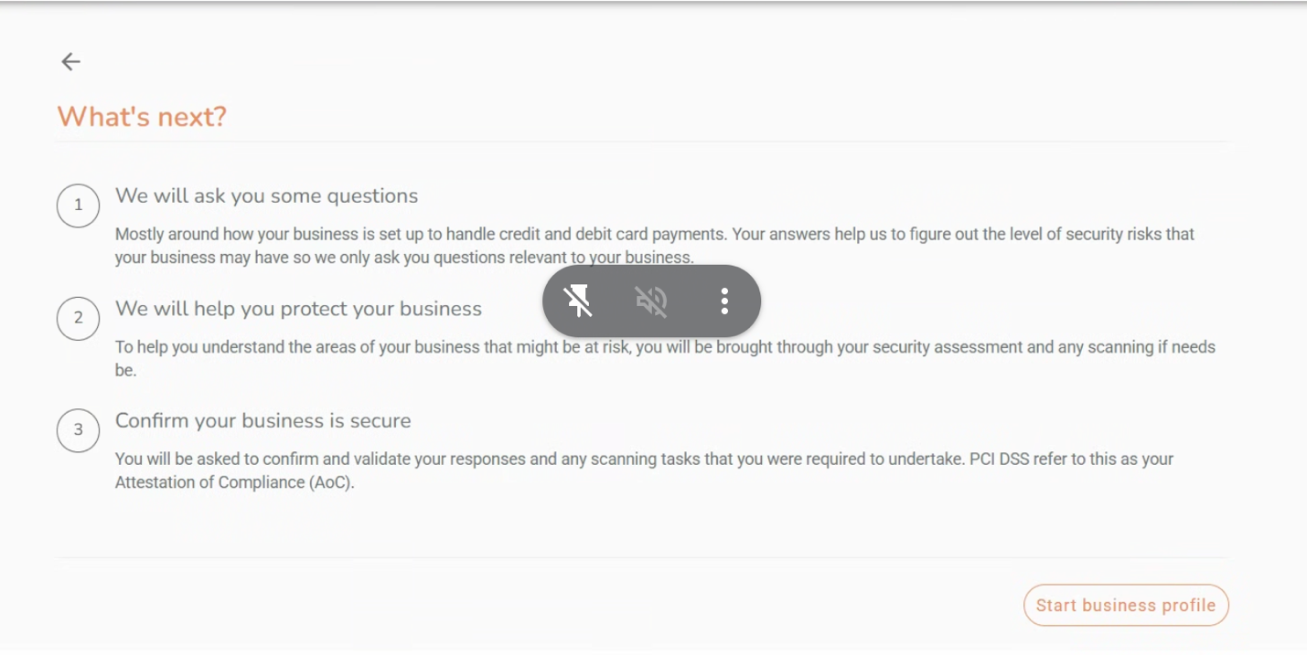

On the next screen, Select “Guide Me,” then click “Next.”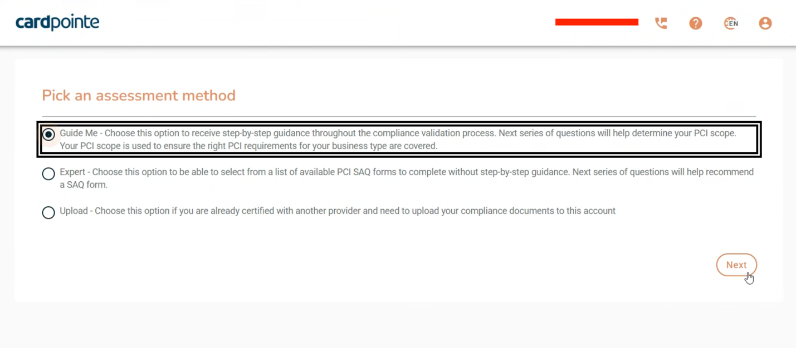

The next question is “What are the ways you accept Credit Card Payments?” Even if you have a local, physical card scanner and are accepting Credit Cards when people physically show up at your office, you still want to select “My business has a website where payments with a credit card are made online.”
Remember, this assessment is ONLY related to how you are using iDonate, and iDonate is not connected to any physical, in-office card readers you may have.

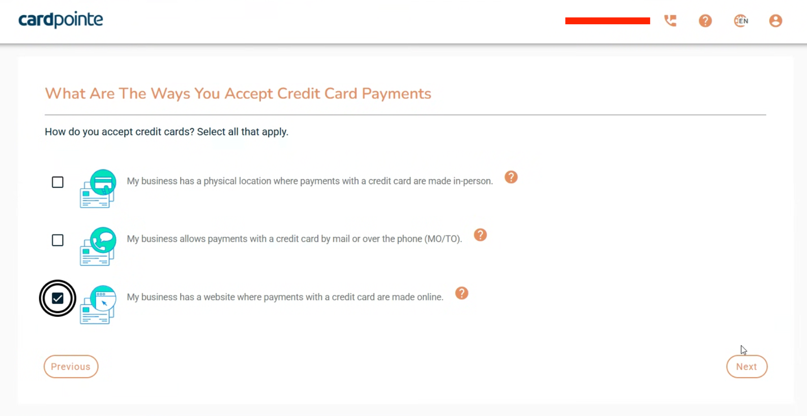

The next Question is about Credit Card Data Storage. It is best practice to avoid writing down Credit Card Numbers. We do encourage entering donations on behalf of a donor, but if you ever write down a Credit Card Number, be sure to shred the document you wrote it on. With iDonate, there is no need for you to save or store Credit Card Numbers. iDonate handles all of this automatically.
The goal here is to avoid the possibility of someone sneaking into an office and stealing someone’s credit card information.
Select “None of the above – I never store credit card data.”

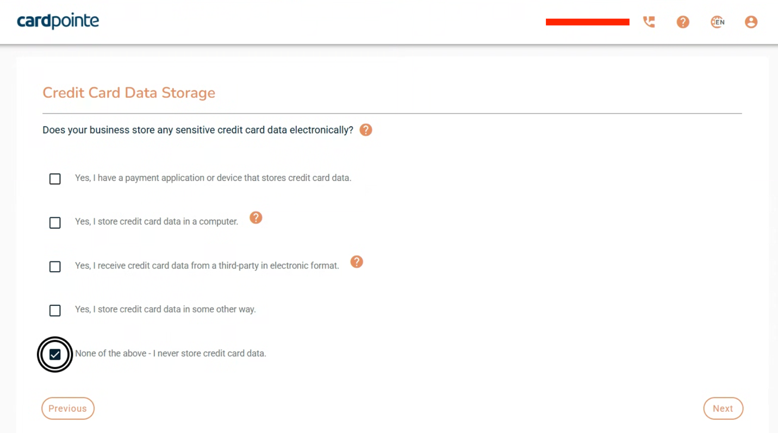

This next question is about Service Providers. Note that it is asking if you share cardholder data with any third-party service Providers. The answer is YES, because iDonate is that 3rd party with whom you share cardholder data.

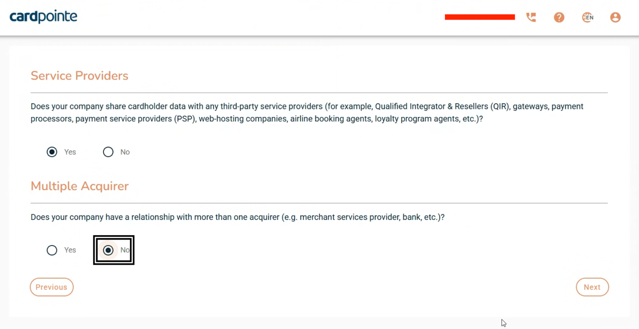
The second question is about Multiple Acquirers, and you should answer NO. iDonate is the ONLY acquirer of your donors’ Credit Card Information before it is passed to the Payment Process.

As seen in the screenshot below, your next step is to enter your company website into the Text Field. You only need to enter one website address, and you only need to enter the address to the Homepage of your website.
Then, click the “Plus” icon to the right.

Then, click “Next.”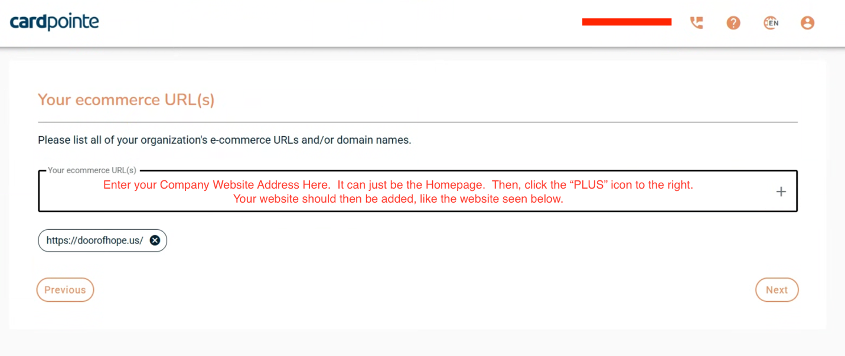

On this next screen, you’ll see 3 Text Boxes. Fill them in exactly as seen below: 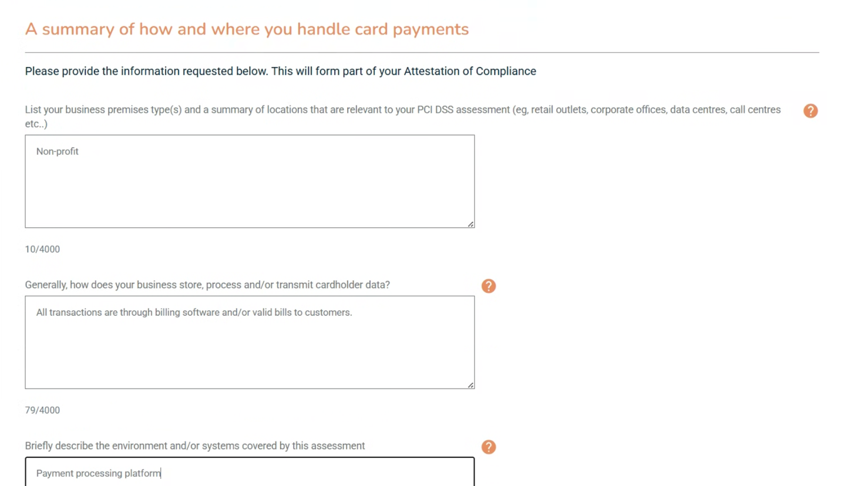
This complete’s your Business Profile. You should now be returned to this screen, and your Business Profile should be listed as SAQ type A:

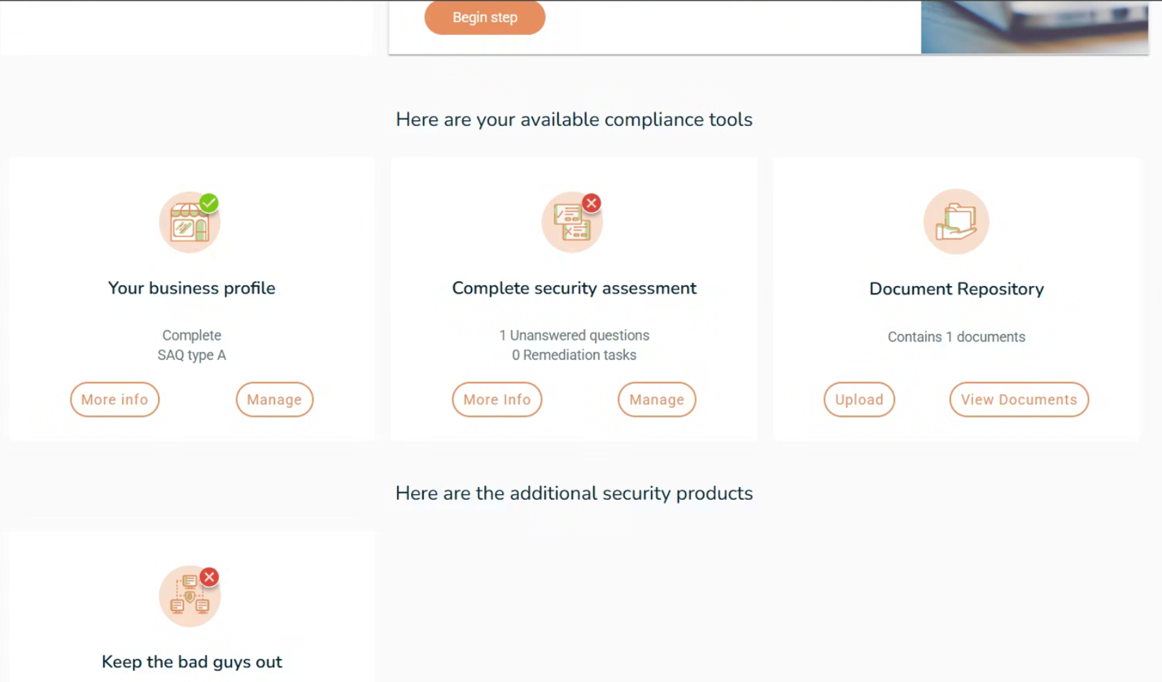

Although your Business Profile is now complete, and you should see a Green Check next to you (as seen above), you still need to complete your Security Assessment.
You can either click the “Begin Step” button at the top, or click the “Manage” button in the “Complete security assessment” card (as seen above).

HOW TO COMPLETE YOUR SECURITY ASSESSMENT

If you’ve followed the steps above and you have an SAQ Type A Business Profile, then you only have 1 Security Question to answer. If you have a Type B, C, or D, Business Profile, then you could have between 40 – 80 Security Questions.
Aren’t you glad you followed my steps?!

This is the first screen you’ll see. Simply choose “Answer Now” to move forward: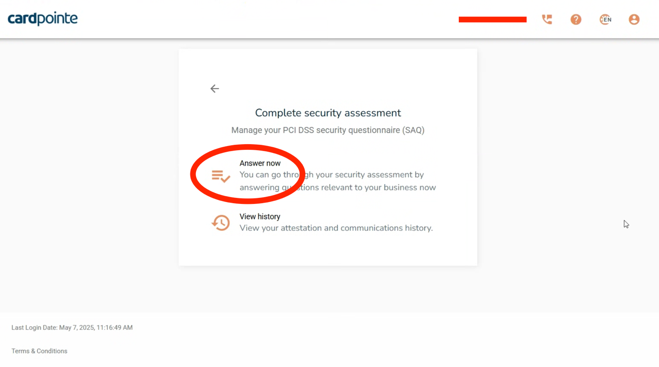

In this next part, you’ll see that it is already set to “Only unanswered questions,” which is great! Answer “Yes” to the one question you are seeing on the screen, then click “Next”:

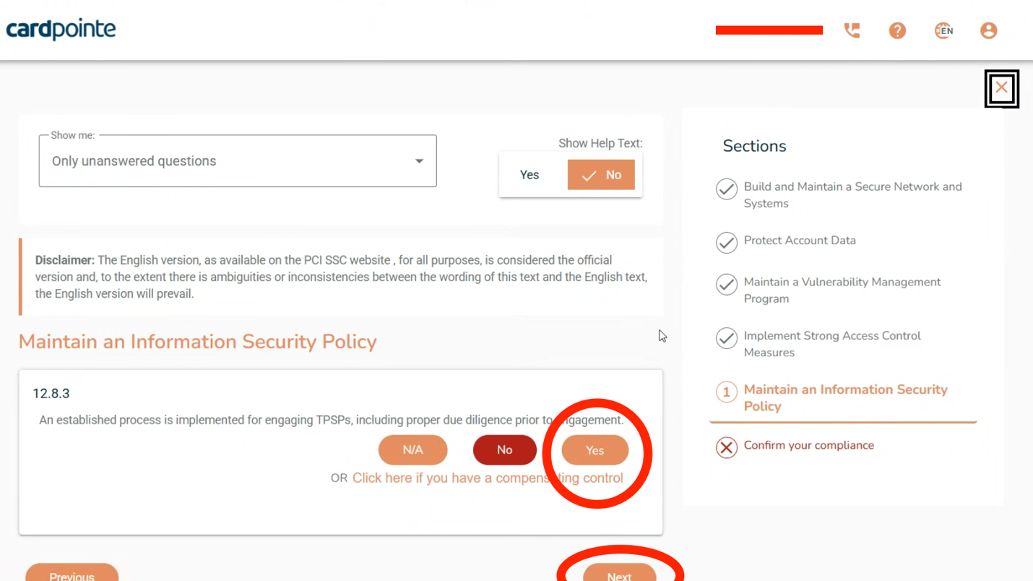

From here, you’ll see that “There are no unanswered questions in this section,” so just click NEXT:
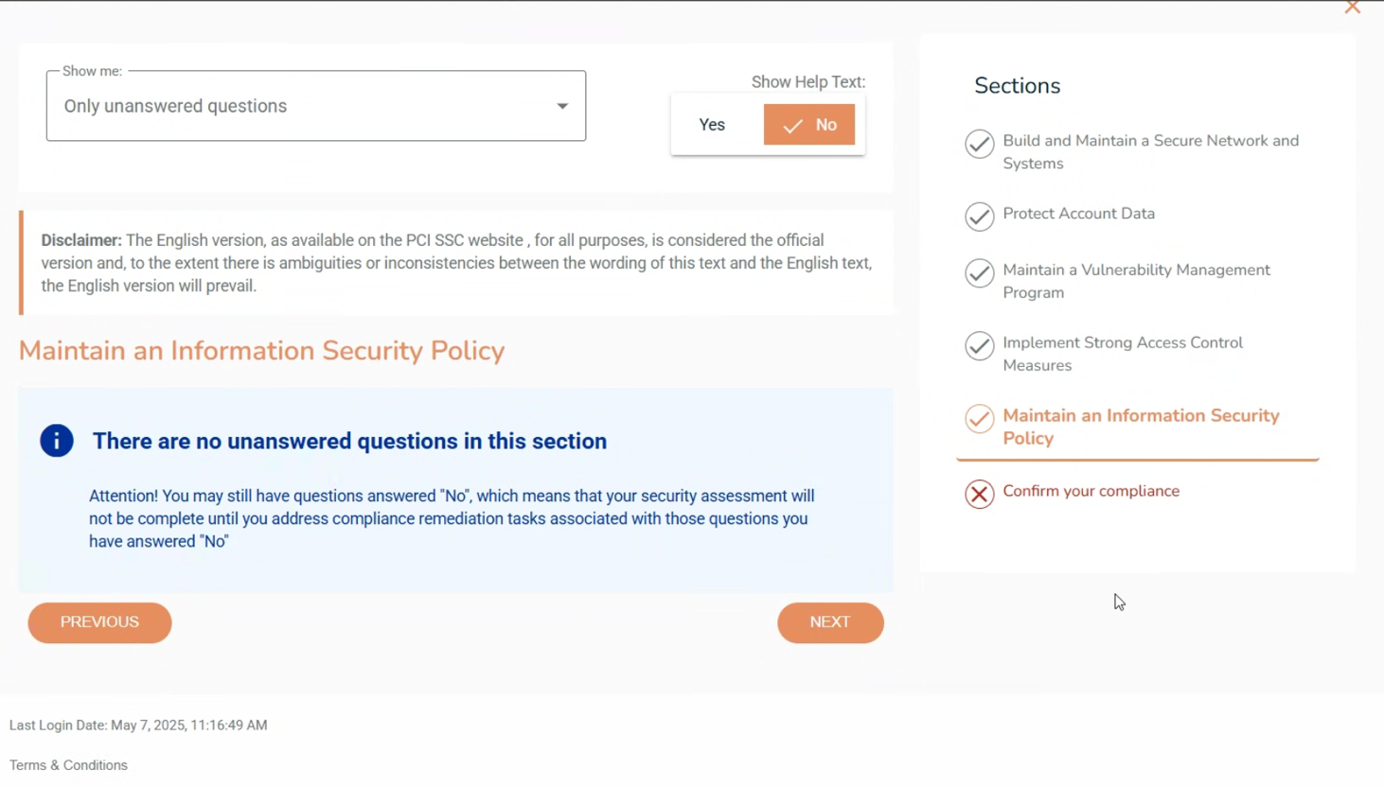

Fill in your Company and Contact Name, Title, Phone, and Email. You cannot edit the Business Address, so if it is wrong move on and we can fix that later.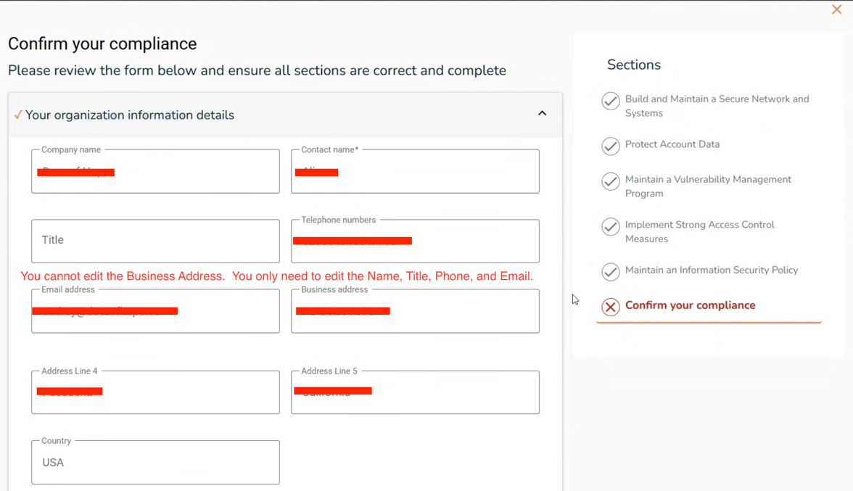

As you scroll down, you’ll see most of the sections are marked with Check Marks. You might see a RED X next to “Merchant Executive Officer.” If so, click there to enter your name and title.

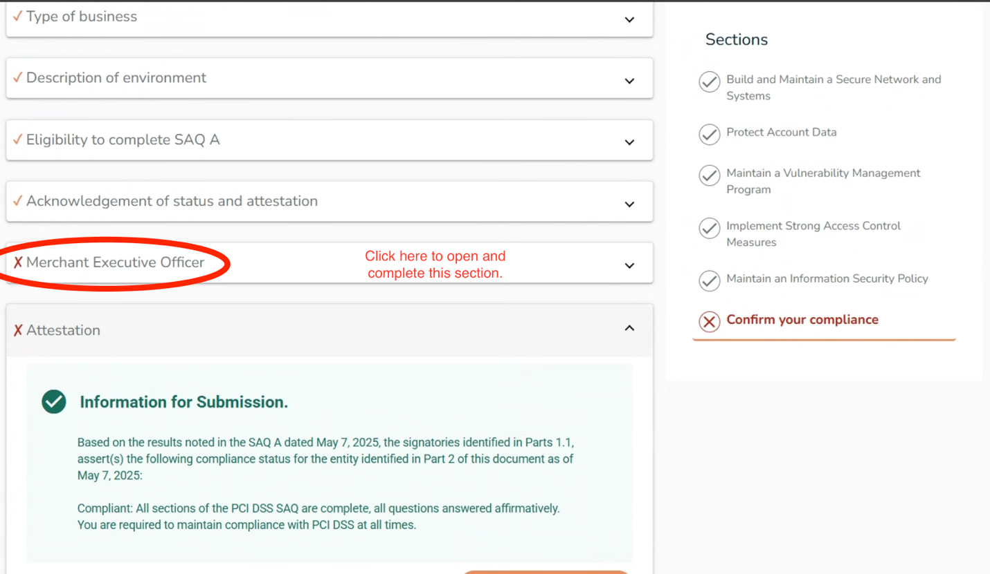

Enter your Name and Title: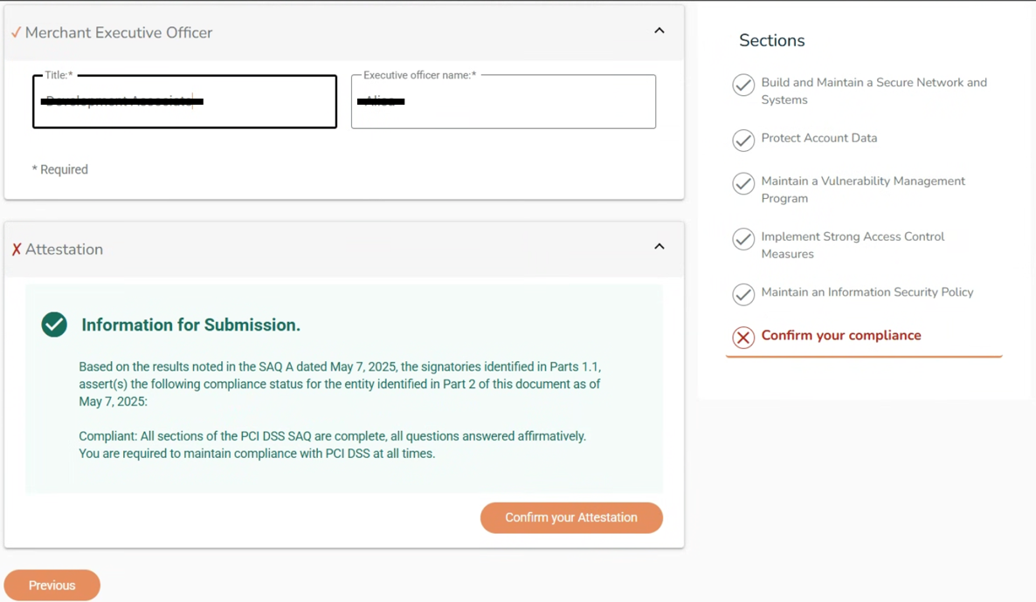

You’ve reached the end! It is time to click “Confirm your Attestation.” (As seen above)

If you did everything right, you should be seeing the screen below. You are now Compliant!!

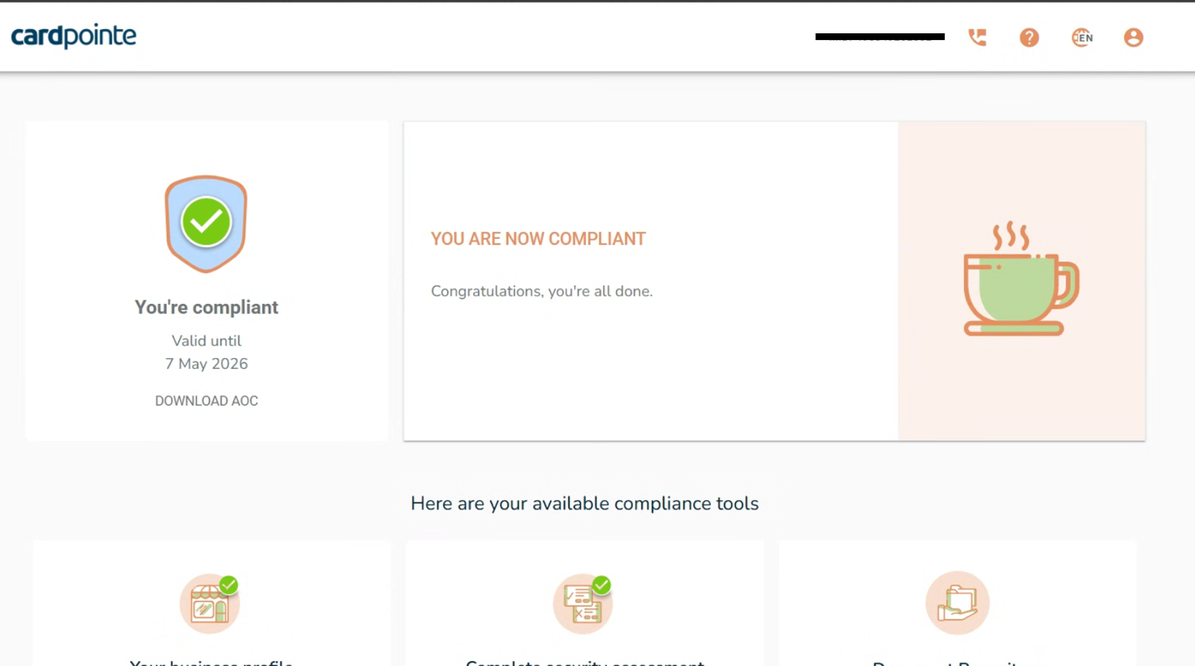

FINAL THOUGHTS:

There will still be 2 sections marked with a Red X. These are the Document Repository and the Keep The Bad Guys Out sections. DO NOT do anything with these. They are NOT REQUIRED with iDonate.

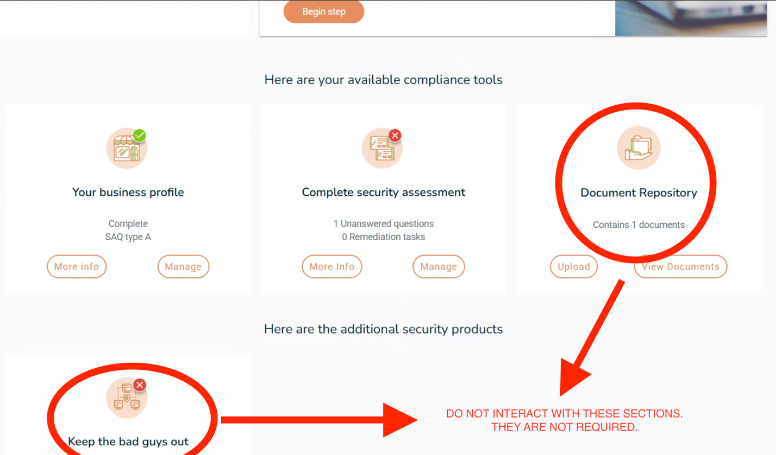

If you need any additional help, you can reach out to Rob Dupree, our in-house PCI Compliance expert. He can be reached at rdupree@idonate.com.

THANK YOU!!

